NAME:Mohith Gowda MR
USN:1RUA25BCA0066
SECTION:B

SQL QUERIES

1.Sample Table: Employee

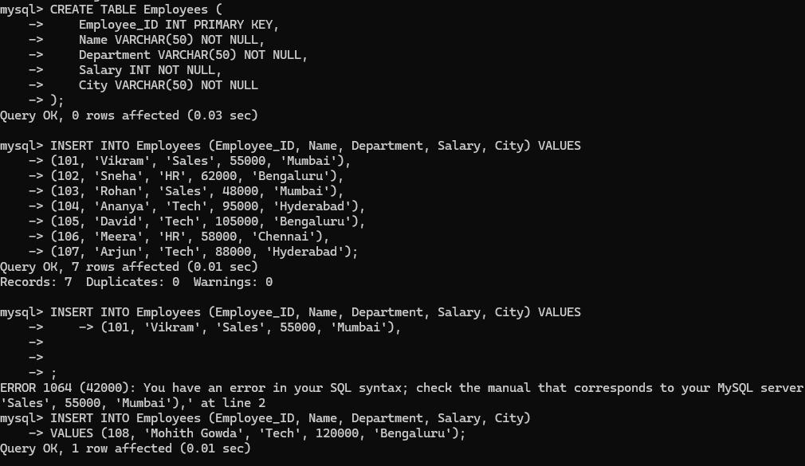

Query 1: Retrieve all students

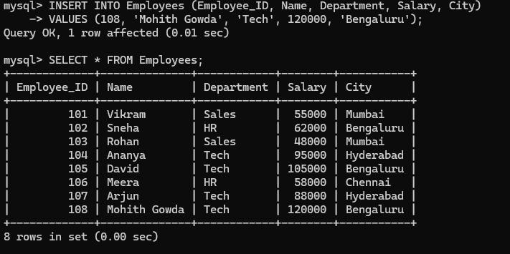

Query 2: Retrieve selected columns

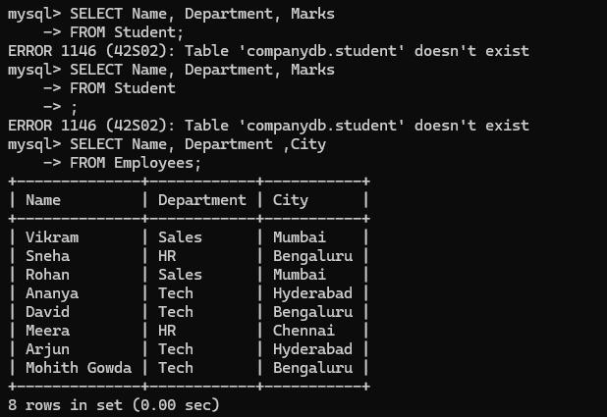

Query 3: Find employees scoring more than 55000

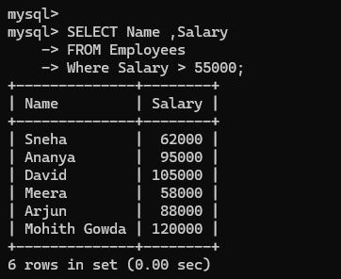

Query 4: Find tech employees

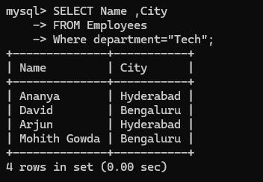

Query 5: Find employees from Bengaluru who scored above 50000

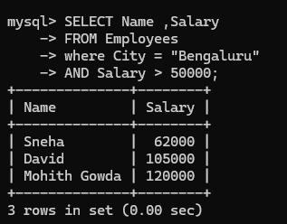

Query 6: Find the highest salary

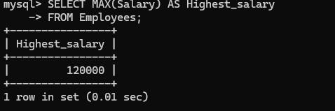

Query 7: Find the average salary

